Low Density Parity Check Decoder

In communication system normally we have message bits and the parity bits added with them in order to send the message to the receiver side. There is a generator matrix which is the implementation of the parity check equations.

G is the generator matrix that generates the code word of the linear block codes.

C=MG

Here, C is the coded message, M is the original message and G is the generator matrix

At the receiver side we have the received message bit and the parity check matrix, from which we decode are message.

In LDPC code there is a property that every code digit is contained in the same no. of equations and each equations contains the same no. of code symbols.

LDPC constructions

LDPC codes are usually represented by the tanner graph. Tanner graph contains two set of vertices

1. n vertices for the code word bits called a bit nodes.
2. M vertices for the check equation called check node.

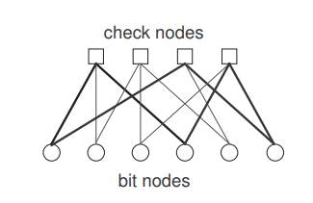

Figure 1: Representation in tanner graph

The following parity matrix is taken in the project

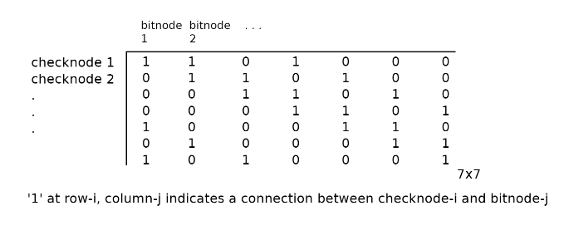

Tanner graph according to the parity matrix is

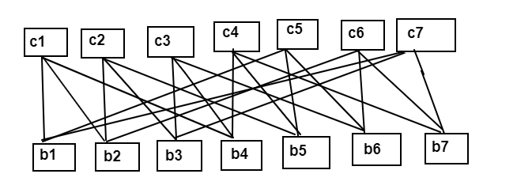

Figure 2: Diagram to show the connection of the bit nodes and check nodes.

ALGORITHM USED

Here we used the Bit Flip algorithm, in which the received message bits are decoded according to the parity matrix and if the bit obtained is not correct, then the respective bit is flipped and then again the equations are checked. The bit flip decoder directly gives it output whenever a valid code word has obtained which satisfies all the parity check equation.

Here the c1 means the first bit of coded word is taking the input from the b1, b2 ,b4, then bit which it will send back to the b0 is the

C1= b1 ⊕ b2 ⊕ b4

C2= b2 ⊕ b3 ⊕ b5

Similarly, the code words are sending the data back to each bit nodes.

As the b1 getting the coded bit from c1, c6 and c7

Now, the bit assigned to the b1 is the majority of the bits which are sended by the c1, c6 and c7.

Like this all the bits have one value assigned to them, now to check whether the decoded messages bits are correct or not all the parity equations should be checked

( b1 ⊕ b2 ⊕ b4) +(b2 ⊕ b3 ⊕ b5)+(b3⊕b4⊕b6)+(b4⊕b5⊕b7)+(b1⊕b5⊕b6)+

(b2⊕b6⊕b7)+(b1⊕b3⊕b7)

If the output of the above equation is zero means the decoded message bits are correct otherwise, it will again send the bit obtained to the check and again do the calculations until the result of the equation is zero.